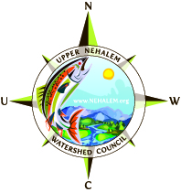

OWEB Project #206-269
Elk Creek – Salmon Passage/Habitat/Riparian Improvement
Final Report- March 2011

(1) A narrative description of the project including:
- Background on the problem that generated the project

The salmon passage, habitat and riparian improvement project is located along Elk creek. Elk creek is a tributary to the East Fork (EF) Nehalem River in the north coast range of Columbia County. Elk creek has a watershed size of approximately 3 square miles and flows into the EF Nehalem at river mile 4.4, and the EF Nehalem enters the Nehalem River at RM 84, approximately 5 miles NE of the town of Vernonia. The primary land use within the EF Nehalem and Elk Creek watersheds is industrial timberland. 68% of the watershed is owned by private industrial wood product companies, 22% is administered by the Bureau of Land Management (BLM), with the remaining 10% of land being owned by private individuals, many of them managing their land for timber production. The geology consists of shallow, highly erodible silt loam soils overlaying sedimentary sandstone and basalt. On steeper slopes these soils are prone to mass wasting and, where disturbance has occurred, surface erosion.

Fish species verified as using the EF system include Coho, Winter Steelhead, Sea-run and Resident Coastal Cutthroat, and Brook and Pacific Lamprey. Elk creek has an average gradient of 1.7% throughout the 3.8 miles of Coho spawning and rearing distribution and has a mean active channel width of 13 feet (ODFW data). The East Fork watershed compares with other coastal watersheds in its Coho habitat characteristics except it contains a large percentage of low gradient habitat. This is unusual given its headwater orientation and suggests potential for excellent Coho habitat supporting a large population (BLM Assessment, 96) and more recently verified by the level of juvenile presence noted in the Upper Nehalem - Rapid Bio-Assessment report (Bio-Survey’s Inc; 08,09,10).

Additional confirmation of Coho use was obtained in December 2010 through the observations of Vernonia Rural Education Corp who witnessed numerous adult Coho entering Elk creek to spawn exclaiming “so many went by we couldn’t count them”, and UNWC staff who photo documented their consistent presence 2 miles upstream. Prior to this project there were no Coho above the McKee road crossing (ODFW, UNWC, RBA)

The limiting factors for watershed health and salmonid production present in the Elk creek sub-basin prior to project implementation included:

- Fish Access: manmade obstacles to fish passage were located in lower reaches of Elk Creek at 2 road crossings, blocking fish migration to approximately 3.6 miles of upstream spawning and rearing habitat and temperature refuge area.

  - Crossing 1 – McKee: sometime in the 1970`s, an asphalt coated galvanized culvert was placed in the stream channel creating the McKee mainline road/stream crossing. The culvert was undersized and acted as a point of constriction, altering the stream hydraulics and channel dynamics, affecting the fluvial geomorphology upstream and downstream of the site. As the continuous stream flow interacted with the point of constriction sediment dropped out above the inflow, velocity through the pipe increased and a plunge pool formation persisted below the outfall, creating an unnatural stair step in the stream gradient and an impediment to upstream migration for migrating salmon, lamprey and amphibians.

  - Crossing 2 – Scappoose/Vernonia Hwy: the lower culvert existed at the Columbia County Scappoose-Vernonia Hwy crossing. Sometime in the 1950’s the original bridge at this Hwy crossing was replaced with a concrete box culvert, installed by the Columbia County Road Department. The culvert was 80ft long and 96in square, with a 12 inch low-flow perch at the outlet. The bottom of the culvert was 100% bare concrete. Outflow pool depth is 24 inches. Culvert slope is 2%, with 1% stream slopes beyond both the inflow and the outflow. Adult passage was inhibited by high velocities during winter flows and lack of bottom roughness, but it was not considered a barrier to adults. Juvenile passage was questionable due to summer perch height, lack of bottom roughness, lack of sufficient summer depth and winter velocities.

- Stream Habitats: within the East Fork watershed are for the most part degraded and simplified, being dominated by riffles and glides. Elk creek is also affected by degraded habitat, but is comparatively in better condition due to the presence of beaver dams and a few degraded LWD accumulations. There exists an overall lack of large and coarse woody debris with-in the active stream channel and floodplain with in the lower reach due to a combination of past management practices including the removal of log jams, riparian cover and beavers. There is a lack of deep pools, large wood and off-channel areas considered important elements of fish habitats.

- Riparian Condition: plant community diversity and a general lack of large conifers in riparian zone exists due to the effects of past timber harvest practices. The current Forest Practices Act no longer allows streamside clear-cuts in the area. The Nehalem Riparian Conditions Analysis (PSU; 01) identified a lack of large conifers in the riparian zone for future large woody debris recruitment. Riparian vegetation was 76% hardwoods and 24% conifers, with all the conifers less than 35 inches DBH. Invasive species, i.e. canary grass, scotch broom and blackberry, are inhibiting the re-establishment of native plant communities.

- Water Quality - Sediment: the geology of the sub-basin consists of shallow, highly erodible silt loam soils overlaying sedimentary sandstone. On steeper slopes these soils are prone to mass wasting and, where disturbance has occurred, surface erosion. The large scale timber harvesting and associated road construction that has occurred on private lands in the last decade seems to have increased sediment yields in the watershed. In the 1980’s a large wind storm uprooted a large number of trees that were then salvaged from the drainage, this activity may have accelerated sediment release. During the 1996 flood event that devastated the Nehalem Watershed the East Fork Nehalem was heavily impacted. As a result, numerous road failures, mass wasting of steep slopes and accelerated stream bank erosion occurred. UNWC was collecting turbidity samples through-out the upper Nehalem basin for several years starting in 1997. Sample collection included several sites in the East Fork Nehalem. In 1997 a noticeable plum of fine sediment was observed flowing from the East fork into the mainstream Nehalem and was visible for several miles downstream.

This prompted those concerned to trace the sediment source up into the sub-basin. The tributary that was producing the most sediment was Elk creek. It was determined that the source of that sediment was from steep slope landslides, that occurred during the 1996 flood event, had settled into the Elk creek system and were flushed out during a heavy rainstorm that occurred in the spring of 1997. With private timber harvest rates declining in the near future, erosion rates should be decreasing over the next 30-40 years, or until the next cycle of heavy timber harvesting begins. An increase in beaver dam complexes (Boswell, 03-05) in the Elk creek drainage has occurred, trapping sediment and reducing sediment loading.

- Water Quality – Temperature: is affected because of the previous extensive clear-cutting of riparian vegetation which was occurring on private industrial lands prior to the Oregon Forest Practice Act (ODF, 71) and due to private landowner grazing practices, once prevalent, in the lower reaches. Reduced buffer widths and lack of conifers is also contributing to the temperature problem by reducing overall year-round shade values and allowing for increased solar exposure and ambient temperatures. The available temperature data (UNWC, BLM) for the EF Nehalem show that the basin standard of 18.4C is exceeded regularly during the summer months. The East Fork Nehalem is on the 303(d) list as water quality limited due to temperature between mile 0 to 9.8 of the mainstream, affecting summer rearing conditions for salmonids. This data was derived in 2 sampling locations on the East Fork Station 1 located near the mouth had 7-day average of daily maximum temperature of 66.7 F degrees. Station 2 located at river mile 6 had a 7-day average of daily maximum temperature of 65.3 F degrees. This is a contributing factor to the listing of the Nehalem Mainstem for temperature with recorded temperatures in the low 70’s during summer rearing season. Temperature data collected by the council shows that Elk creek is a cool water source in the EF Nehalem. Elk creek is a potential summer refugia for juvenile salmonids escaping higher temperature conditions that exist in the mainstream Nehalem and the East Fork.

- A description of the work done, placing it in its larger watershed context;

Three specific problems associated with the limiting factors discussed above were addressed by this project.

This project removed the fish passage barrier to upstream reaches of Elk Creek at the McKee mainline crossing, and improved stream habitat complexity and riparian conditions to 1,300 feet associated stream reach (approx. 1,000 feet above and 300 feet below the crossing). A separate project was completed for the Scappoose Vernonia Hwy salmon passage improvement. That project was completed in the summer of 2010.

Site 1: Salmon passage improvement – McKee mainline/Elk Creek – Summer 2008 - Winter 2010.

NW Natural Gas Company moved the gas line from the road bed down under the natural stream grade in the summer of 2008.

Weyerhaeuser removed the 72 inch round culvert barrier culvert in the summer of 2008 re-establishing a naturalized stream channel that allowed for unconditional juvenile and adult passage. Adult fish were identified migrating to upstream habitats that first winter and juvenile Coho were finally seen upstream of the crossing as far as 3.5 miles. with completion of the downstream passage project on the Highway, this last spawning season saw numerous adult Coho throughout the extent of Elk creek.

Columbia County took ownership of McKee mainline forest road at the Elk Creek crossing in the fall of 2010 and Tristan Wood the county engineer promptly developed a bridge crossing design, hired a construction contractor and oversaw the completion of the Elk Creek crossing. At long last, with great relief and celebration, the crossing was completed two days before the 12-31-2010 OWEB deadline.

The acquisition of this section of the McKee mainline and completion of this crossing was a critical piece to completing the connectivity of the Crown Zellerbach trail system that will eventually connect with the Banks/Vernonia Linear Park Trail in Vernonia and extend to Scappoose.

Site II: Salmon habitat improvement – Summer 2010. (See attached ODFW photo/restoration report).
ODFW Restoration biologist – Michele Long oversaw the placement of 55 logs in 12 locations within the 1,200 feet of Elk Creek for implementation in summer of 2010. 4 key pieces per structure. 20 of the logs used were 33’ long and 24” dbh. Weyerhaeuser – Steve McNulty acquired the logs from Wey co. lands and hired the LWD contractor Eric Hepler Inc., who did a fine job of placing the logs in September of 2010.

Site III: Riparian improvement – Winter 2010.
In order to provide for future recruitment of conifer to active stream channel and floodplains the council will work with landowners to improve riparian condition and wildlife habitat by under planting existing riparian management area with native conifers, hardwoods and shrubs. Trees and some shrubs were protected against wildlife damage by protective tubes secured by bamboo stakes and zip ties. Invasive vegetation will be removed from around each plant until established. Most of the conifer and hardwood plant materials used were obtained from the BLM – North Coast Native Plant Cooperative and most of the shrub/ground cover wildlife species were purchased from Watershed Gardens. Plants from the coop are grown from local seed sources collected in the wild by council volunteers and BLM staff and grown to a healthy vigorous condition to improve survival rate in the wild.

The plant materials used:
Ground cover; 30 bleeding heart, 30 douglas iris, 15 kinnikinnic, 50 sword fern, 10 salal,
Shrubs; 40 oceanspray, 20 mock orange, 20 serviceberry, 30 douglas spirea, 20 oregon grape, 10 pacific rhododendron, 30 nootka rose, 20 snowberry, 20 twinberry
Small trees; 10 pacific yew, 20 vine maple, 20 crab apple, 20 cascara, 20 ninebark
Conifer; 150 western red cedar, 735 sitka spruce,
Hardwoods; 100 oregon ash
Supplies used: 373 mesh tubes, 180 protex tubes and 1106 bamboo stakes
Area planted: 10,000 + square feet along both sides of along 600+ foot reach

- A description and explanation of any changes to the original proposal;
During the course of this project several twists and turns have occurred.

The project was originally proposed to UNWC by Steve McNulty of Weyerhaeuser Company in 2004 a project proposal was then developed and submitted to OWEB for funding in the 2006 cycle. During the project development stage Weyerhaeuser originally made a verbal commitment to cover 50% of the construction costs of placing a log truck bearing bridge at the crossing. By this time Wey Co had made personnel adjustments and UNWC was working with a different engineer who assisted with developing the preliminary designs and then another yet personnel shift occurred. During the time the third Wey Co rep was on board with the project had been discovered that the NW Natural Gas line (main feed to Vernonia) was in the road bed at the crossing and would have to be moved according to new standards.

The NW Natural Gas line relocation was not incorporated into the planning or budget of the OWEB grant so other means had to be developed. The original NW Natural Gas Co. estimate to move the line was reported to be $125,000 and was later determined reduced to $56,000. Weyerhaeuser and NW NG Company had numerous high level discussions with their attorney’s attempting to determine right-of-way and who would be responsible for the costs of moving the line which delayed the project for a year or more.

At some point NW Natural made a deal with Columbia County (who was negotiating with Wey Co. to acquire that section of the McKee mainline for the Crown Zellerbach Trail system) to donate $56,000 to the county to move the line. The county in return made arrangements with UNWC to donate the $56,000 to UNWC and we

in return had to guarantee to NWNG Co. that we would pay $56,000 to NWNG Co. to move the line. This transaction, after much delay and persistence, was made complete in the winter of 2009.

Deed transfer of a section of the McKee mainline from Weyerhaeuser to Columbia County for the Crown Zellerbach Trail was completed in October of 2010. A celebration occurred ;-).

- A description of any efforts under taken to promote the project;

The project was promoted on multiple levels of Columbia County government, with-in Weyerhaeuser Company and ODFW, and through the UNWC project manager reporting to board, UNWC project tours and local newspaper coverage.

- Lessons learned from the project

The project was unexpectedly delayed over the course of four years by a series of seemingly unproductive negotiations between the legal counsel of NW Natural Gas Company and Weyerhaeuser regarding resistance in setting legal right-of-way and financial precedence in the moving of the gas line and between Columbia County and Weyerhaeuser Company involving the implications of liability in the indemnification language in the deed transfer of the McKee mainline to Columbia County for the Crown Zellerbach trail. UNWC project manager and key persons with-in Weyerhaeuser (Steve McNulty, Scott Marlega) and Columbia County (including the Road Master – Dave Hill, Glenn Crinklaw – Parks Director and Tony Hyde - Commissioner) spent a fair amount of time and effort encouraging the different entities to progress in the negotiations so the project could be completed before the OWEB grant expired. Partnership, persistence and patience pays off!

- Recommendations for more effective implementation of similar projects.

Always identify location of utilities during the initial field reconnaissance efforts. Aspirin required ;-)

(2) Documentation that the project complies with the Oregon Aquatic Habitat Restoration and Enhancement Guide.

See attached Letter from ODFW – Michele Long 3-4-2011

(3) Slides or photographs of the project areas before and after the project completion taken at pre-set photo points as described in the publication “Photo Plots Guide”.

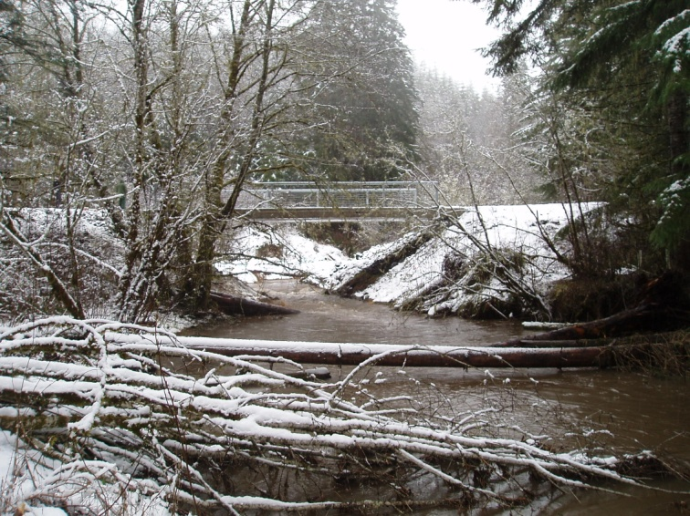
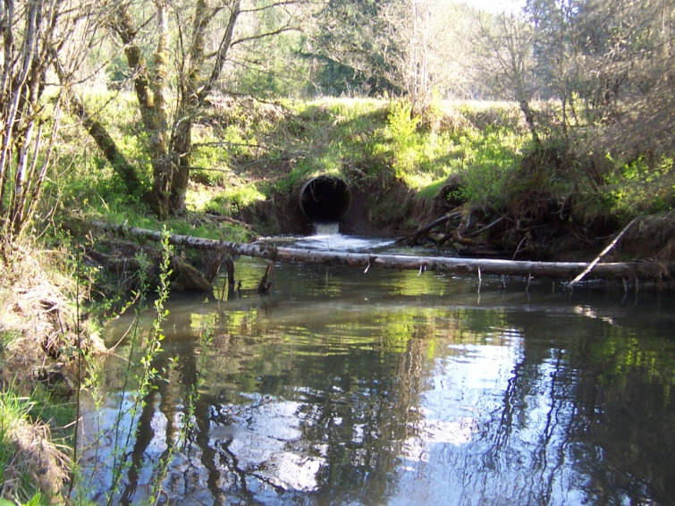
Elk Creek/McKee crossing – after – winter 2011

Elk Creek/McKee crossing - before

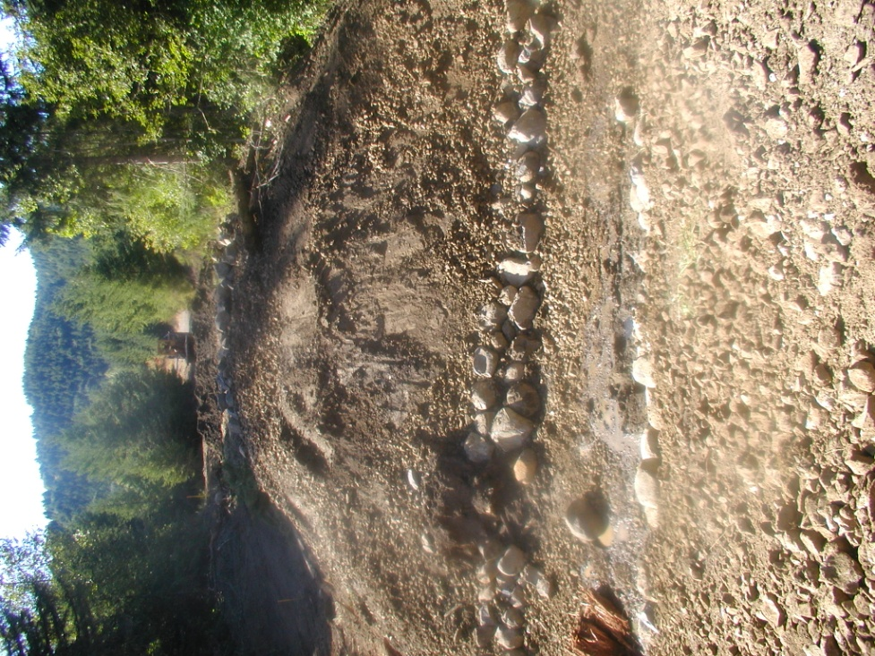
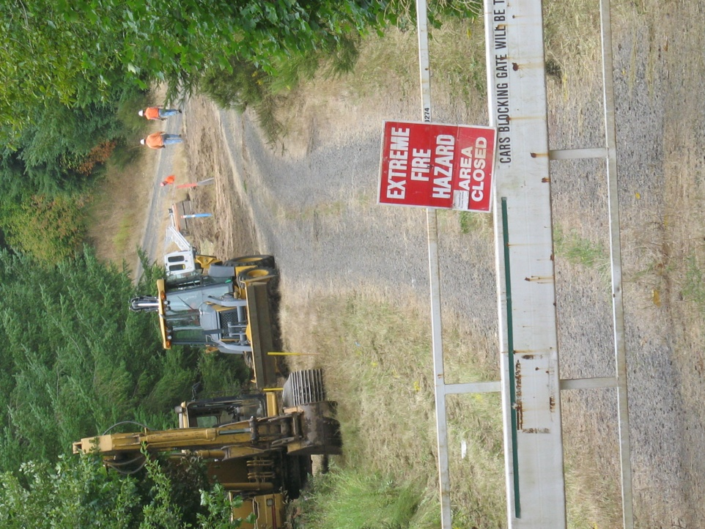
Wey Co. – culvert removal - summer 2008
NWNG Co. moving gas line -summer 2008
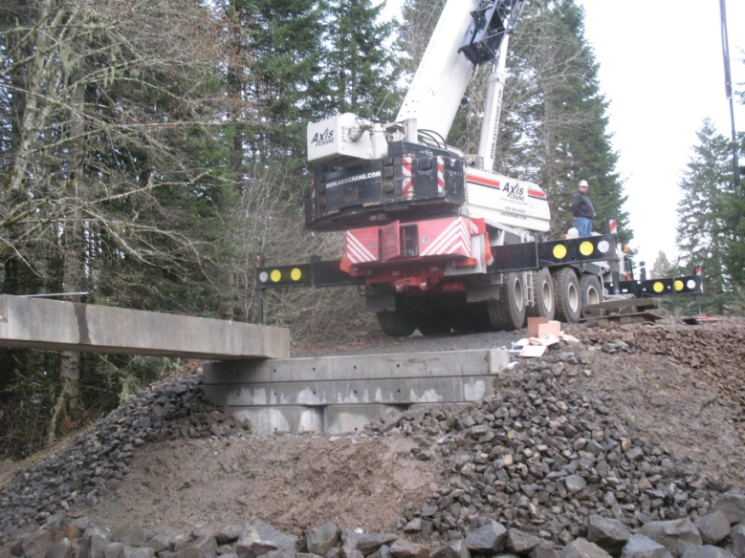
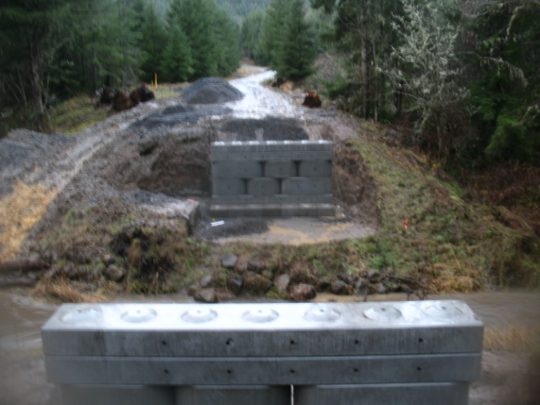
Columbia County contractor – building bridge – Winter 2010

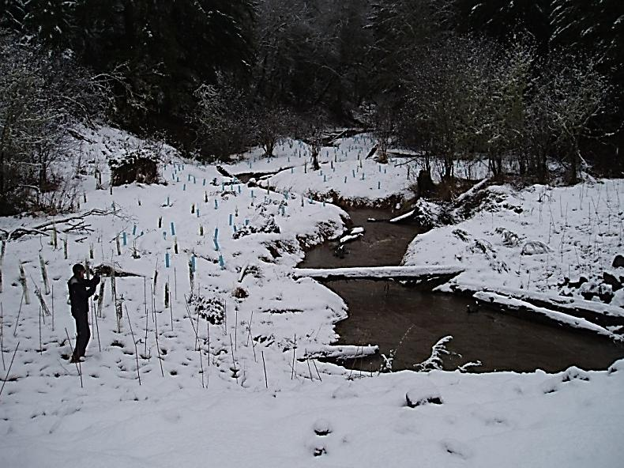
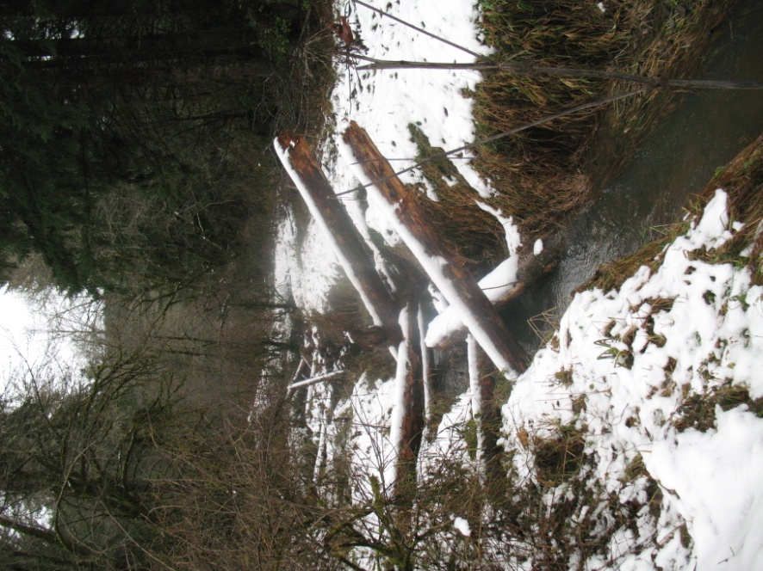
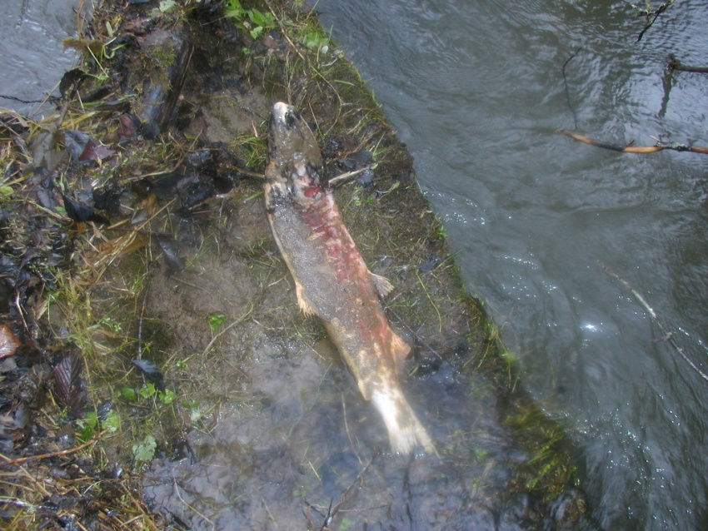
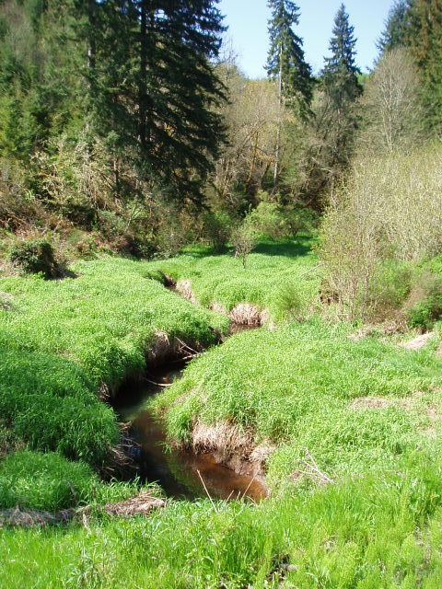
Dead Coho spawner – above crossing - December 2010
Riparian planting – completed December 2010
LWD placement site – February 2011
Riparian – before – summer 2006

(4) Exhibit H: The most current version, provided on the Board’s Web site, of the Oregon Plan Watershed Restoration Reporting Form completed and submitted with the required map to OWEB.

See attached.

(5) An accounting of the expenditures of Board monies and all other funding in the project, including a final accounting of all in-kind contributions, donations and the required non-OWEB 25% match funds

See attached.

